

Configuring Access Points for Fortinet Firewall Environment

Rui Zhao, CCNA
Purpose:

The purpose of configuring Access Points (AP) for a Fortinet firewall environment is to establish secure wireless connections for both personal and business use. Fortinet firewalls can be deployed for enterprise-grade connectivity, combined with WPA2 Personal and Enterprise policies, giving access to secure and encrypted seamless wireless connection while enforcing appropriate levels of authentication.

Background Information:

In 2000, a cybersecurity company Fortinet was officially founded in Sunnyvale, California by brothers Ken and Michael Xie. After marketing and selling their first product, a physical FortiGate firewall, they have expanded their expertise and products in access points, security, and sandbox technology. Today, Fortinet has become one of the most prominent cybersecurity companies, serving over 900,000 customers globally, with 15.9 million units of products at the end of 2025. Additionally, they offer next-generation firewalls that have features such as wireless LAN, FortiGuard AI-powered security services, and SaaS solutions for management.
Fortinet is a security ecosystem and offers many sorts of different products and services. They emphasized in integrating wireless systems into next-generation firewalls, offering different features in order to control the network and cybersecurity. With their integration of the cloud, further expanding their significant role in the ever-growing enterprise IT infrastructure, getting access to cloud providers such as AWS, Microsoft Azure, and Google Cloud Platform. Furthermore, Fortinet has its own cloud-native security tools, called the FortiCNAPP platform, allowing security management with the many different cloud providers.
Comparing Fortinet to other firewall vendors, Fortinet heavily focuses on integrating products together. Furthermore, using multiple Fortinet products will further increase security and threat detection. It isn’t only suitable for SOHO environments, but also enterprise-grade solutions for large organizations.
Fortinet also directly competes with the leading competitors like Cisco, Palo Alto Networks, and Check Point. Combining many different Fortinet systems and ecosystems will grant you access to many different features.
With the integration of their Fortinet access points (AP), networks were able to experience the secure enterprise wireless access experience with automated threat response. With Fortinet’s Secure Networking, they were able to provide a secure LAN with simple licensing schemes and low costs.
This is further facilitated by the uprising of virtual machines. For example, integrating Oracle VirtualBox allows users to have a virtual machine that operates for free on an open-sourced hosted type 2 hypervisor. This allows multiple OS integration, which is massive for cybersecurity sectors as they operate tasks in Linux. However, it is still important to consider the responsibility of using this service as it can introduce risks if you have misconfigured network settings incorrectly.
Furthermore, a FreeRADIUS (Free Remote Authentication Dial in User Service) server can be utilized for Oracle VirtualBox too, which helps maintain WPA2 Enterprise. In fact, FreeRADIUS is responsible for the authentication of a third of all users on Internet as a radius server is required for WPA2 Enterprise.

Lab Summary:

In this lab, we configured WPA2 Personal and WPA2 Enterprise through a Fortinet firewall environment. We have used Oracle VirtualBox as our virtual machine and hosted the FreeRADIUS server to use for our WPA2 Enterprise security protocol and successfully deployed two SSIDs.

Lab Commands:

First, head over to Wifi & Switch Controller Managed FortiAPs.

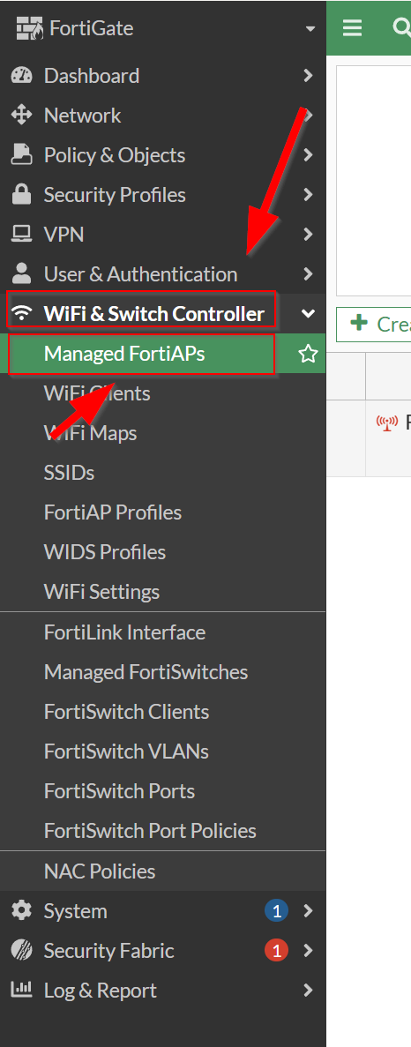

Then, authorize your connected Access Point by selecting your AP Authorization Authorize.

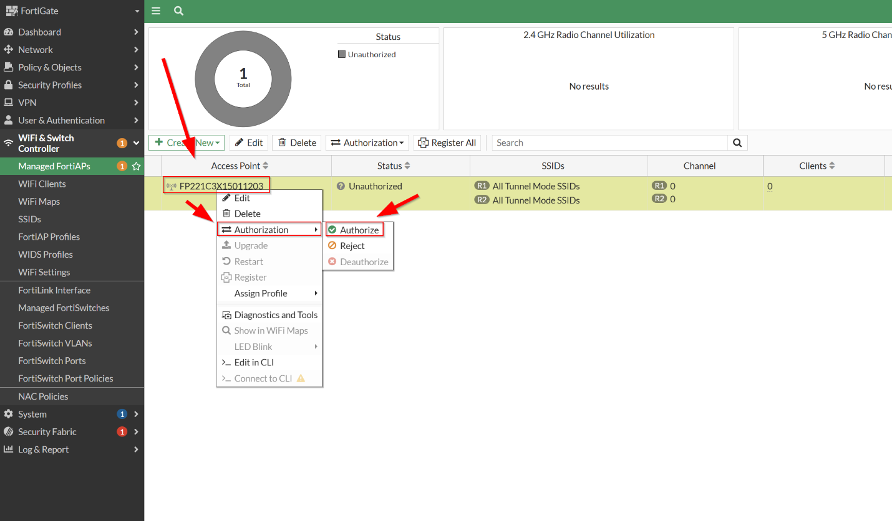

Now your Access Point is authorized. You can inspect its connection status by glancing over to the right.

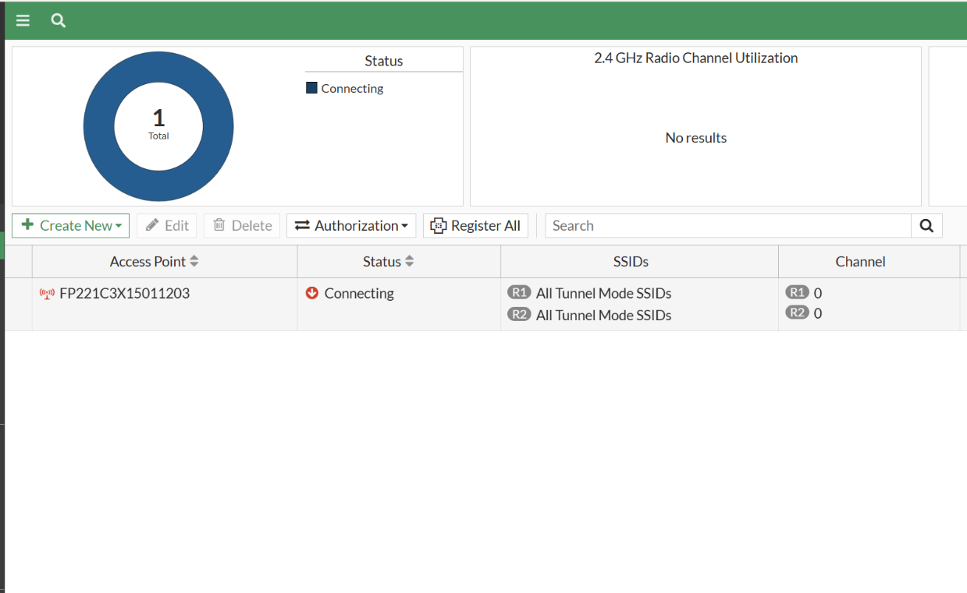

To create our SSID groups, head over to SSIDs Create New SSID.

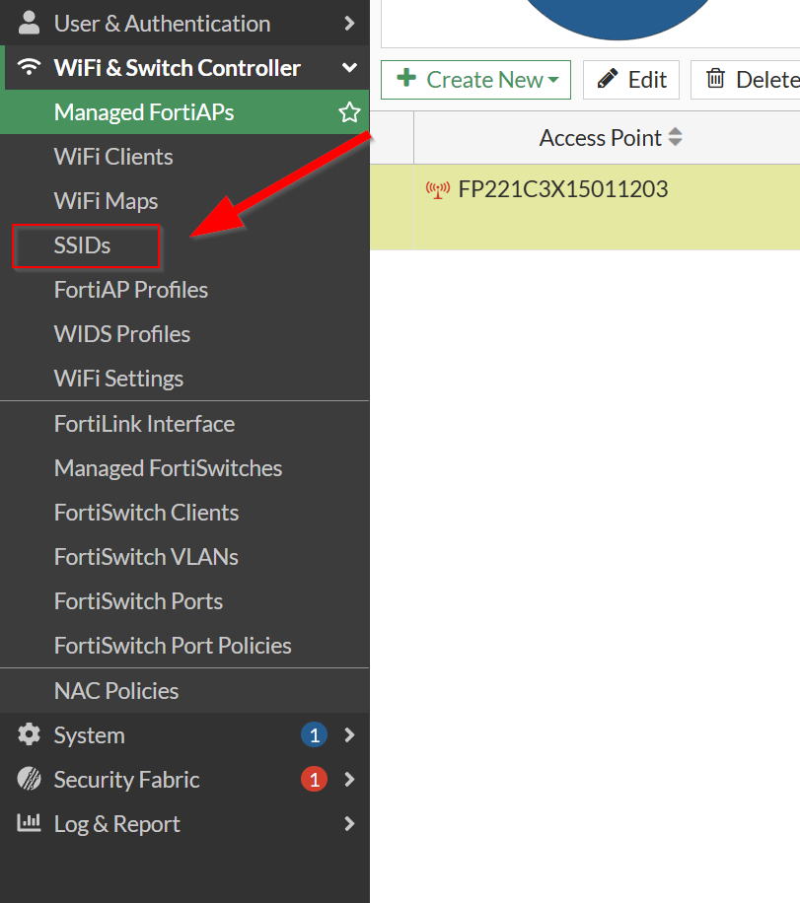

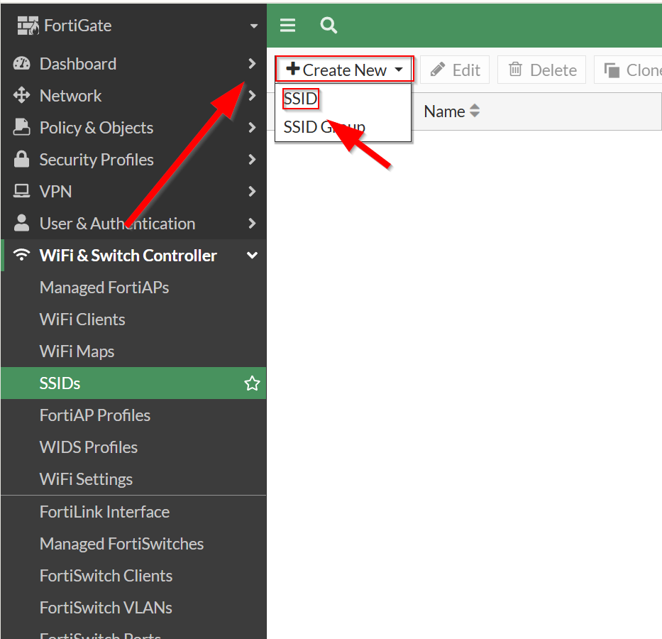

We will be first making a WPA2 Personal SSID. Give the SSID its IP/Netmask. Enable the DHCP Server so it can distribute addresses specified in the address range below. Then, name your SSID and Broadcast it (that will be the name of your WiFi). Then, make sure we check WPA2 Personal for Security mode and put our Passphrase (password) into the SSID. Then, click OK when finished.

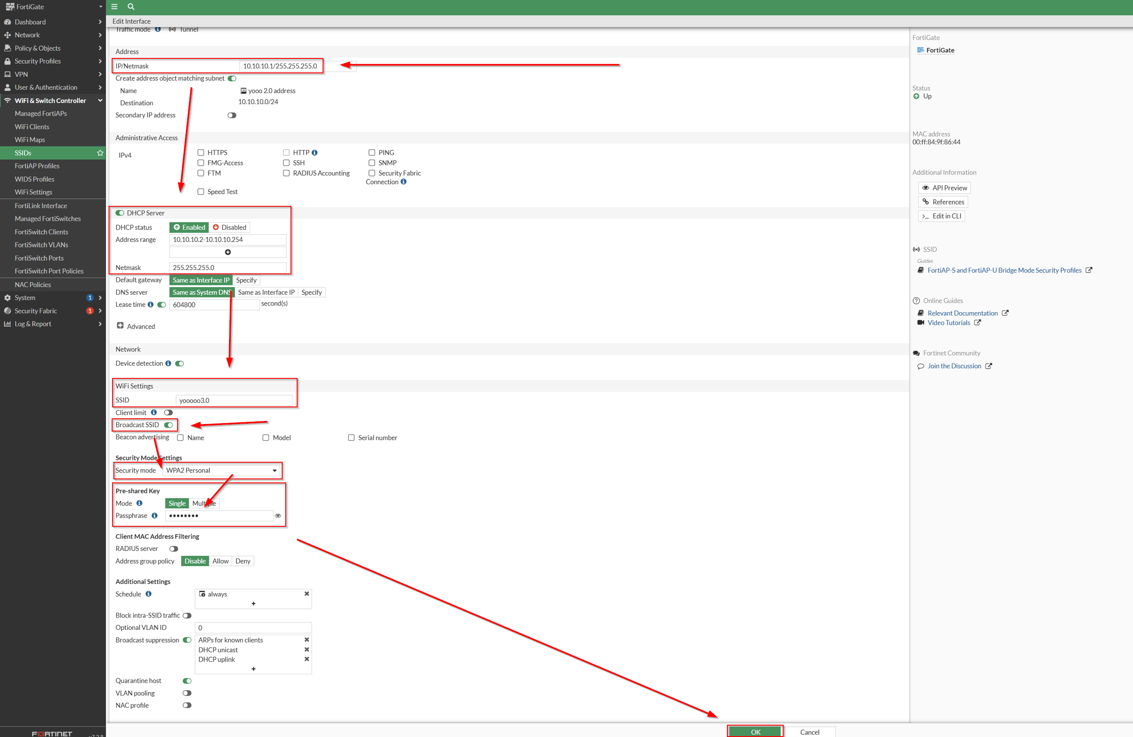

Next, we will start to install a FreeRADIUS server for WPA2 Enterprise. Go to the Ubuntu Server and download the Ubuntu 26.04 LTS Server from https://ubuntu.com/download/server.

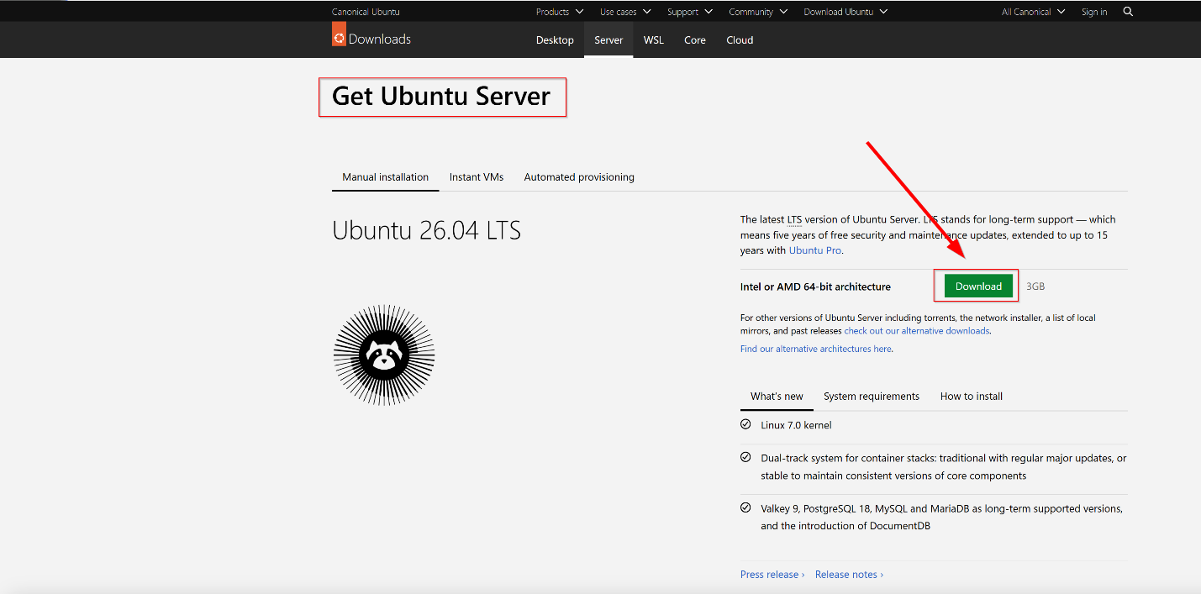

Also head over to VirtualBox and download Oracle VirtualBox here: https://www.virtualbox.org/

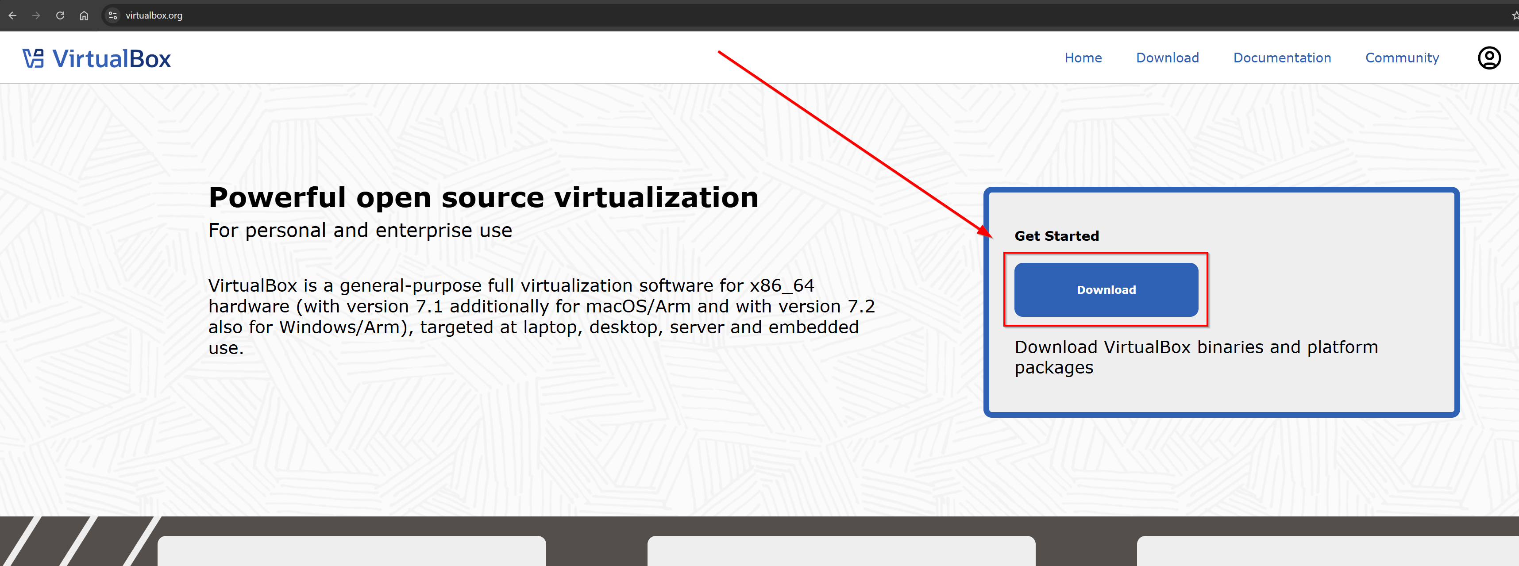

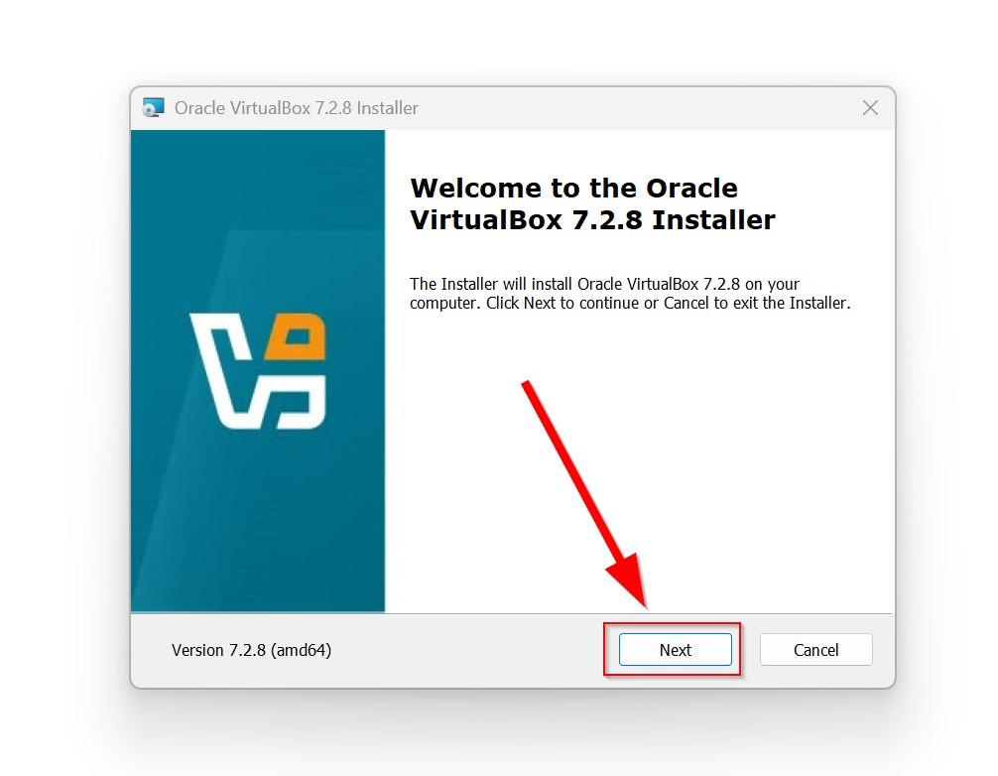
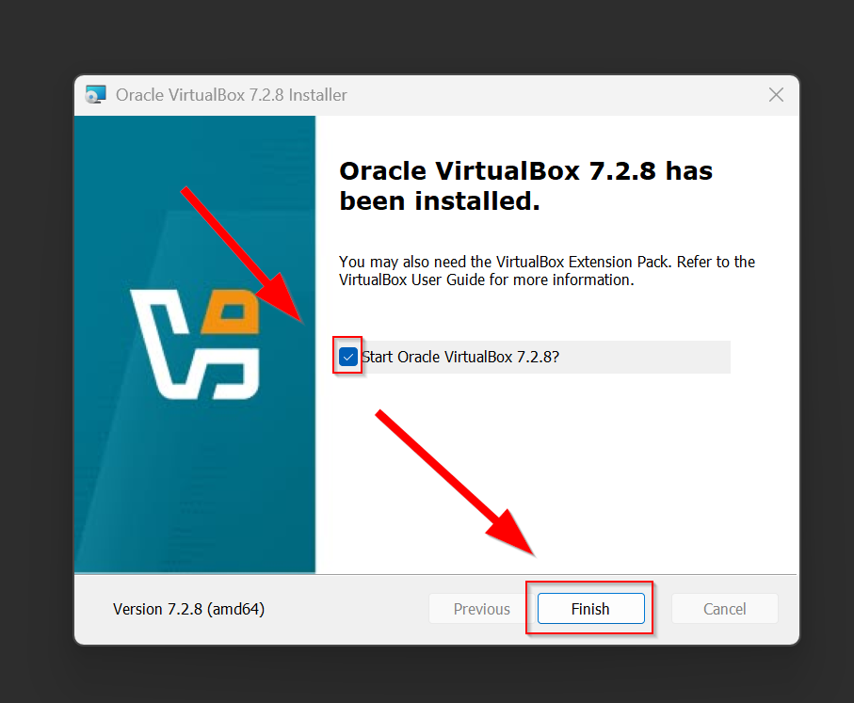

Next, open up Oracle VirtualBox and navigate through New VM Name Select Ubuntu ISO Image (downloaded in the steps earlier) Finish.

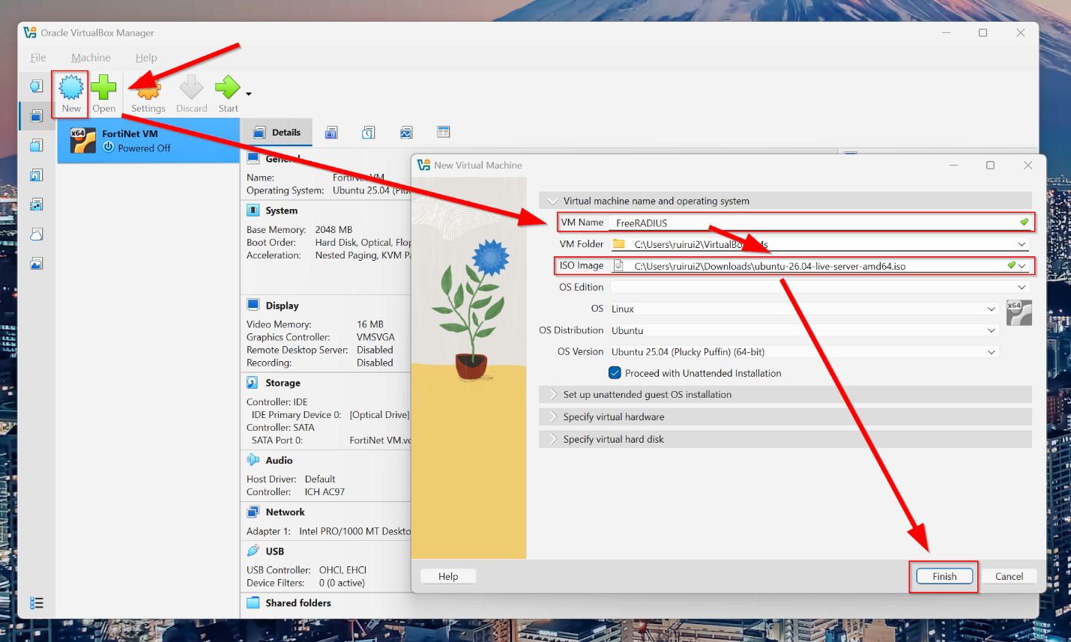

Next, customize the username and password for the virtual machine. Give the Host Name a name (FreeRADIUS for simplification) and press Finish.

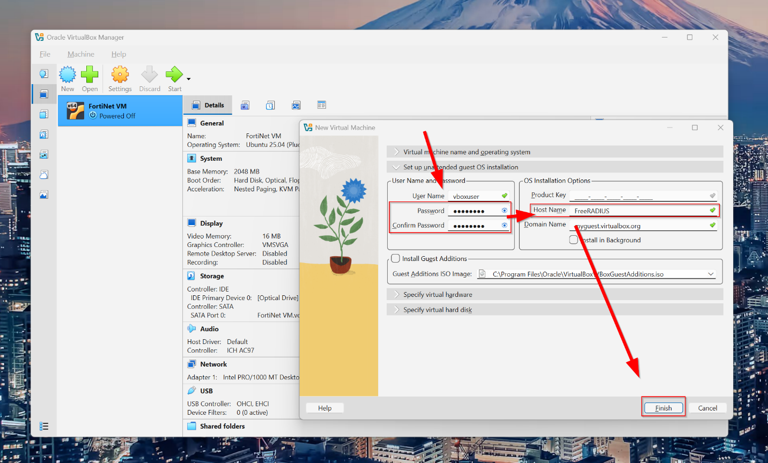

Head over to Settings Expert Network Attached to “Bridged Adapter” OK.

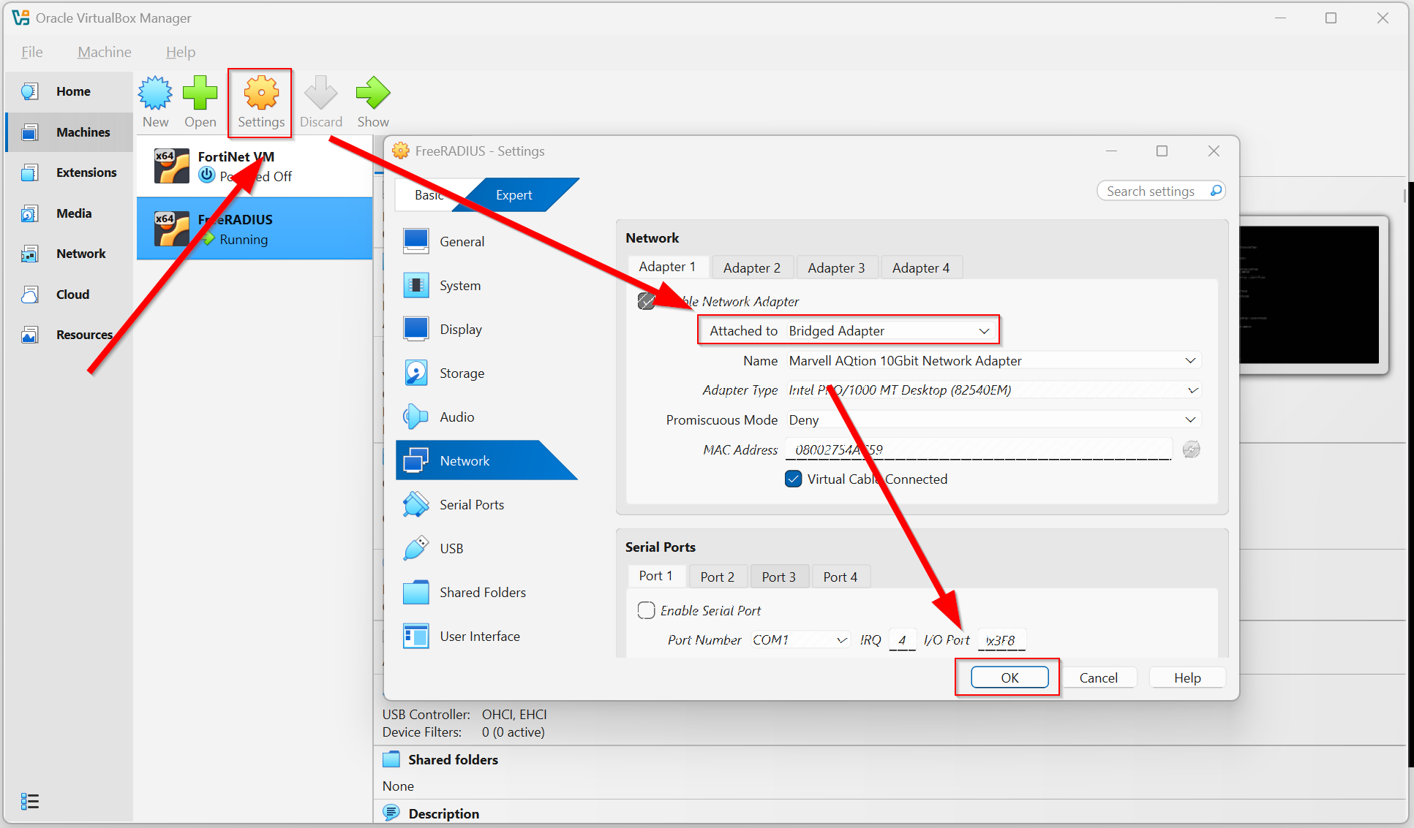

Double click on FreeRADIUS to run the application. When it first initially ran, it will take a few minutes to set up.
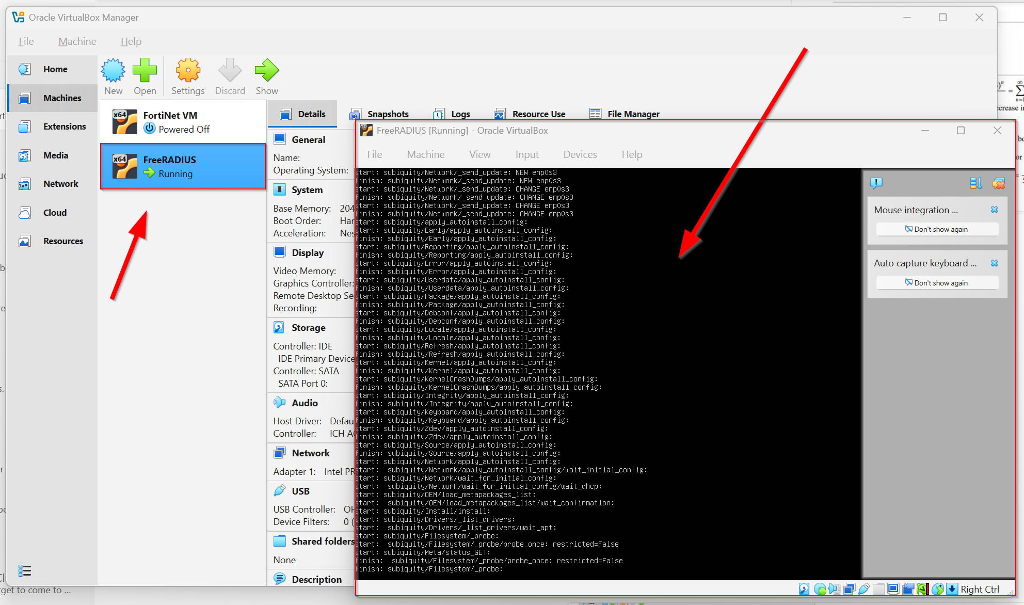

Once it’s done, it should prompt a login.

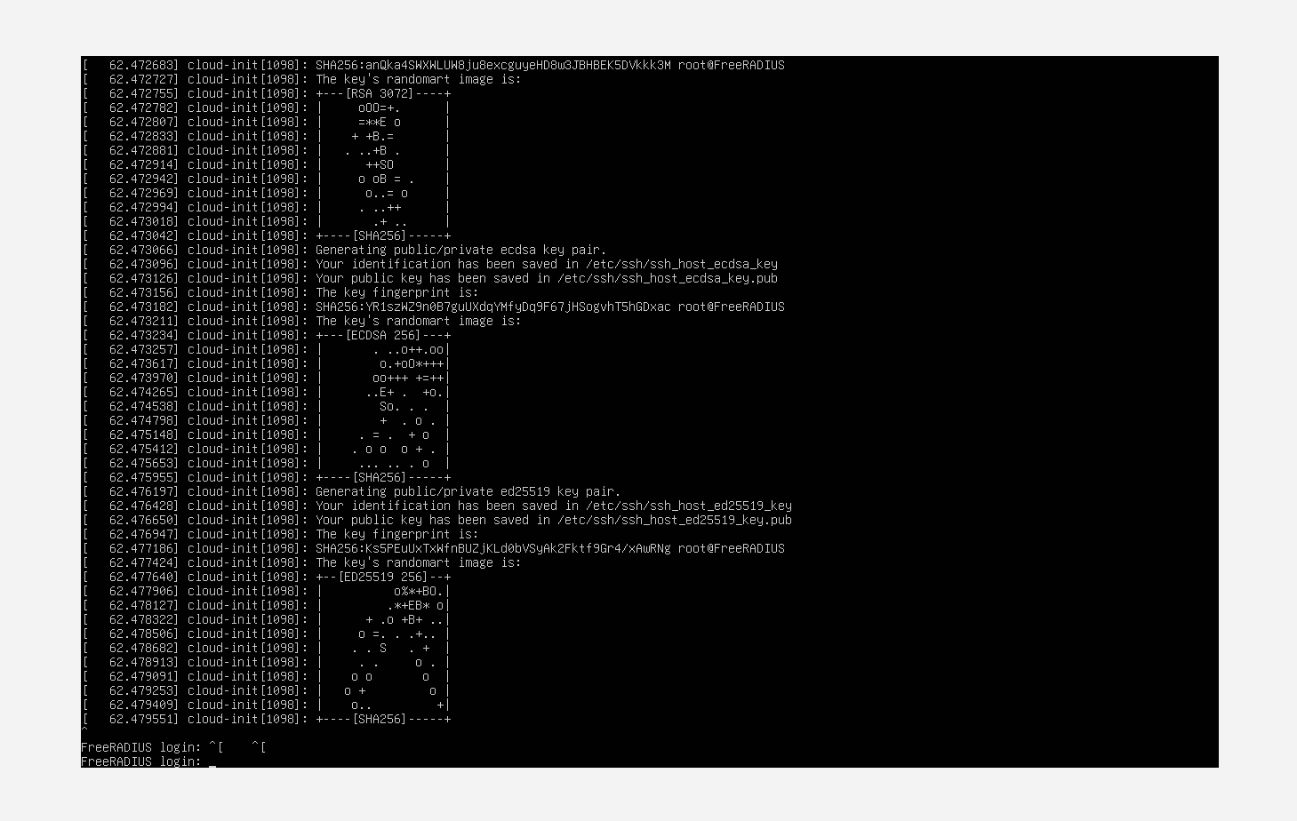

Login with your user credentials established in the earlier steps. Then, run sudo apt update to refresh local database of available software packages for Ubuntu Linux.

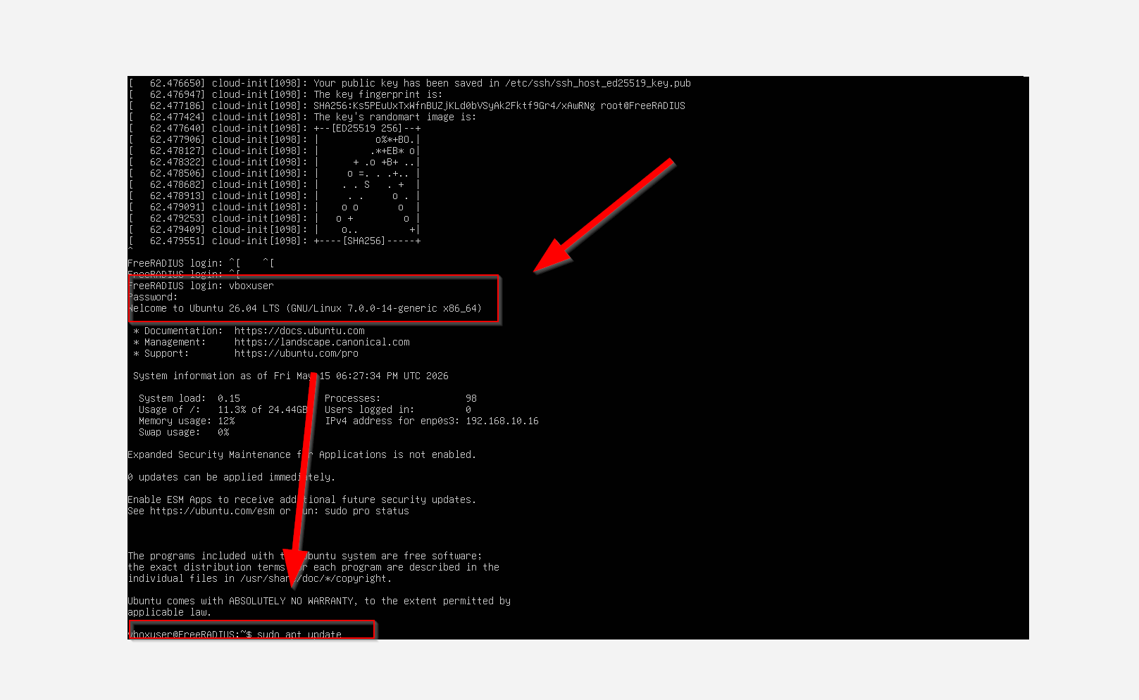

Then, install FreeRADIUS via sudo apt install freeradius -y.

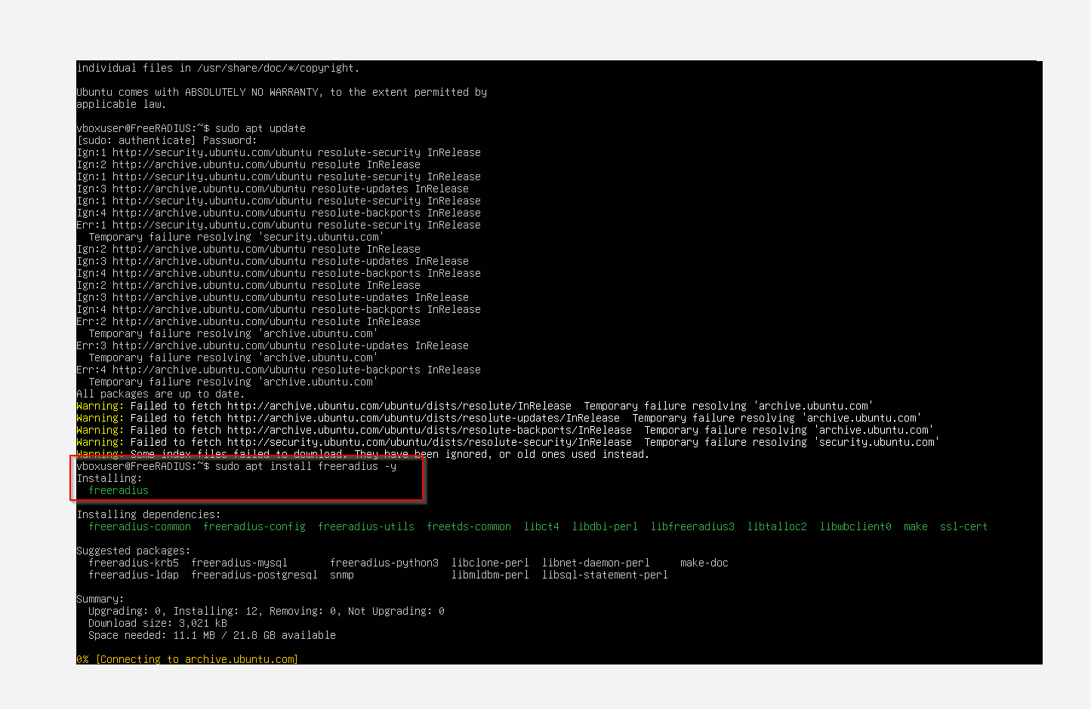

Then, run this command to configure the clients. sudo nano /etc/freeradius/3.0/clients.conf. After that, on the bottom type in our client information exactly as below. Then, CTRL + O (save) Enter CTRL + X (exit).

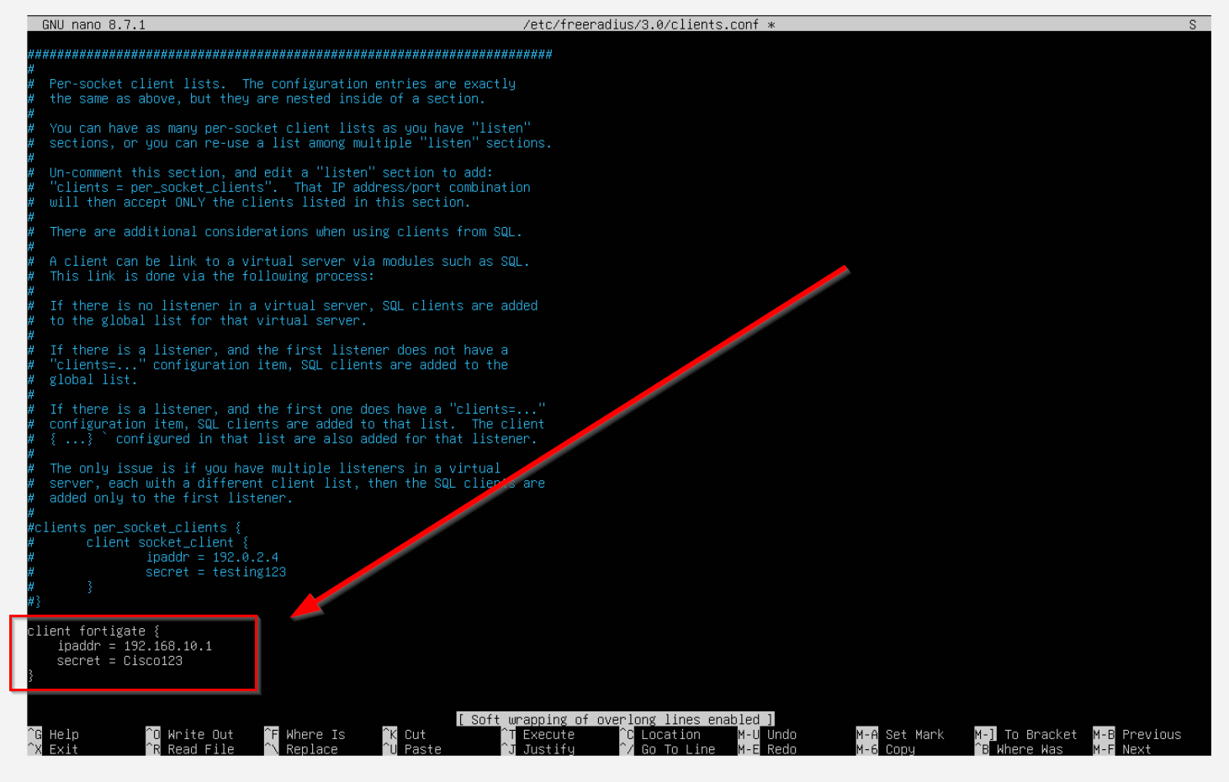

Next, we need to configure the test users. Put this command in. sudo nano /etc/freeradius/3.0/users. Then, go to the bottom again and add testuser Cleartext-Password := "password123". Then, CTRL + O Enter CTRL + X.

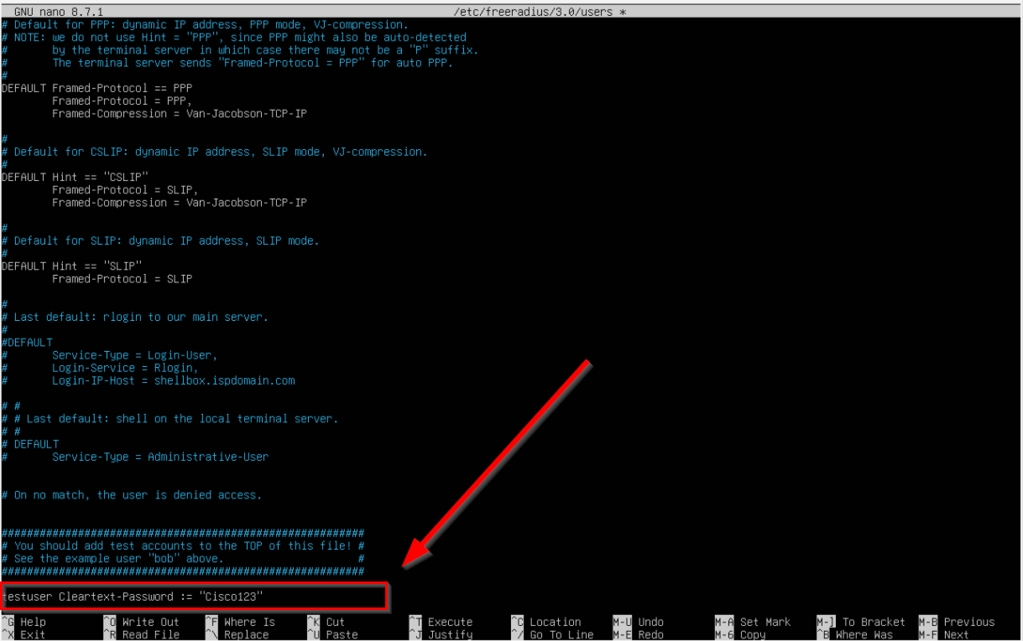

Next, go back to Fortinet. We will be making our WPA2 Enterprise Radius. Go through Wifi & Switch Controller SSIDs Create New SSID.

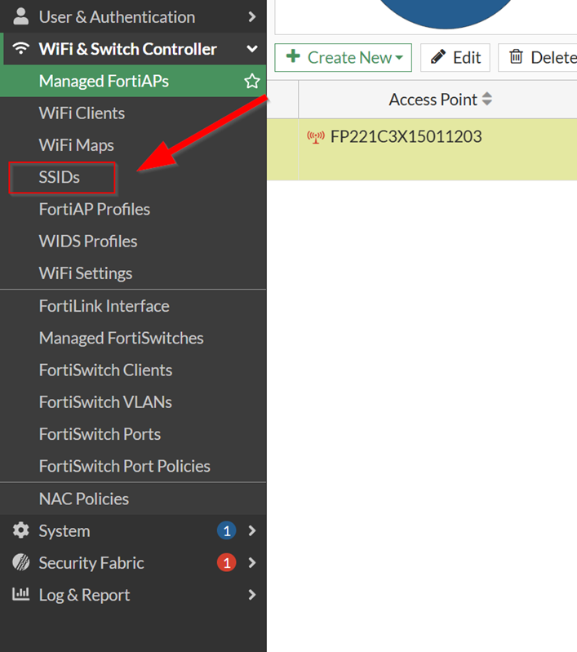

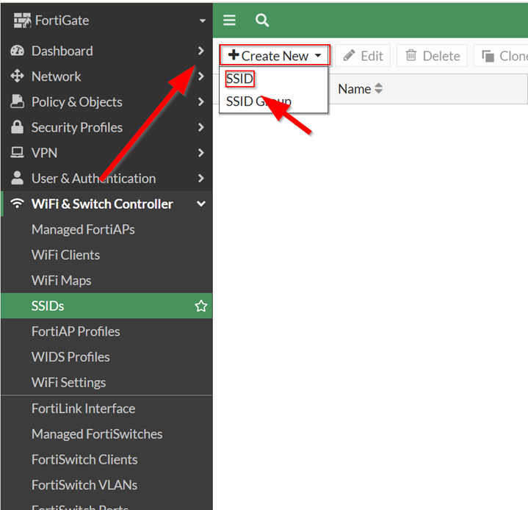

Then, copy the following settings. Make sure you have integrated the Radius server in.

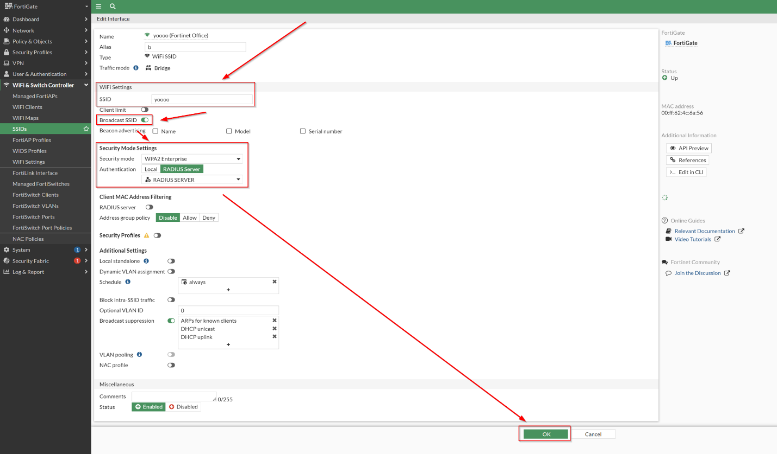

Next, we need to edit our FortiAP Profile to activate our SSIDs. Head over to Wifi & Switch Controller FortiAP Profiles Right click your FortiAP Profile Edit.

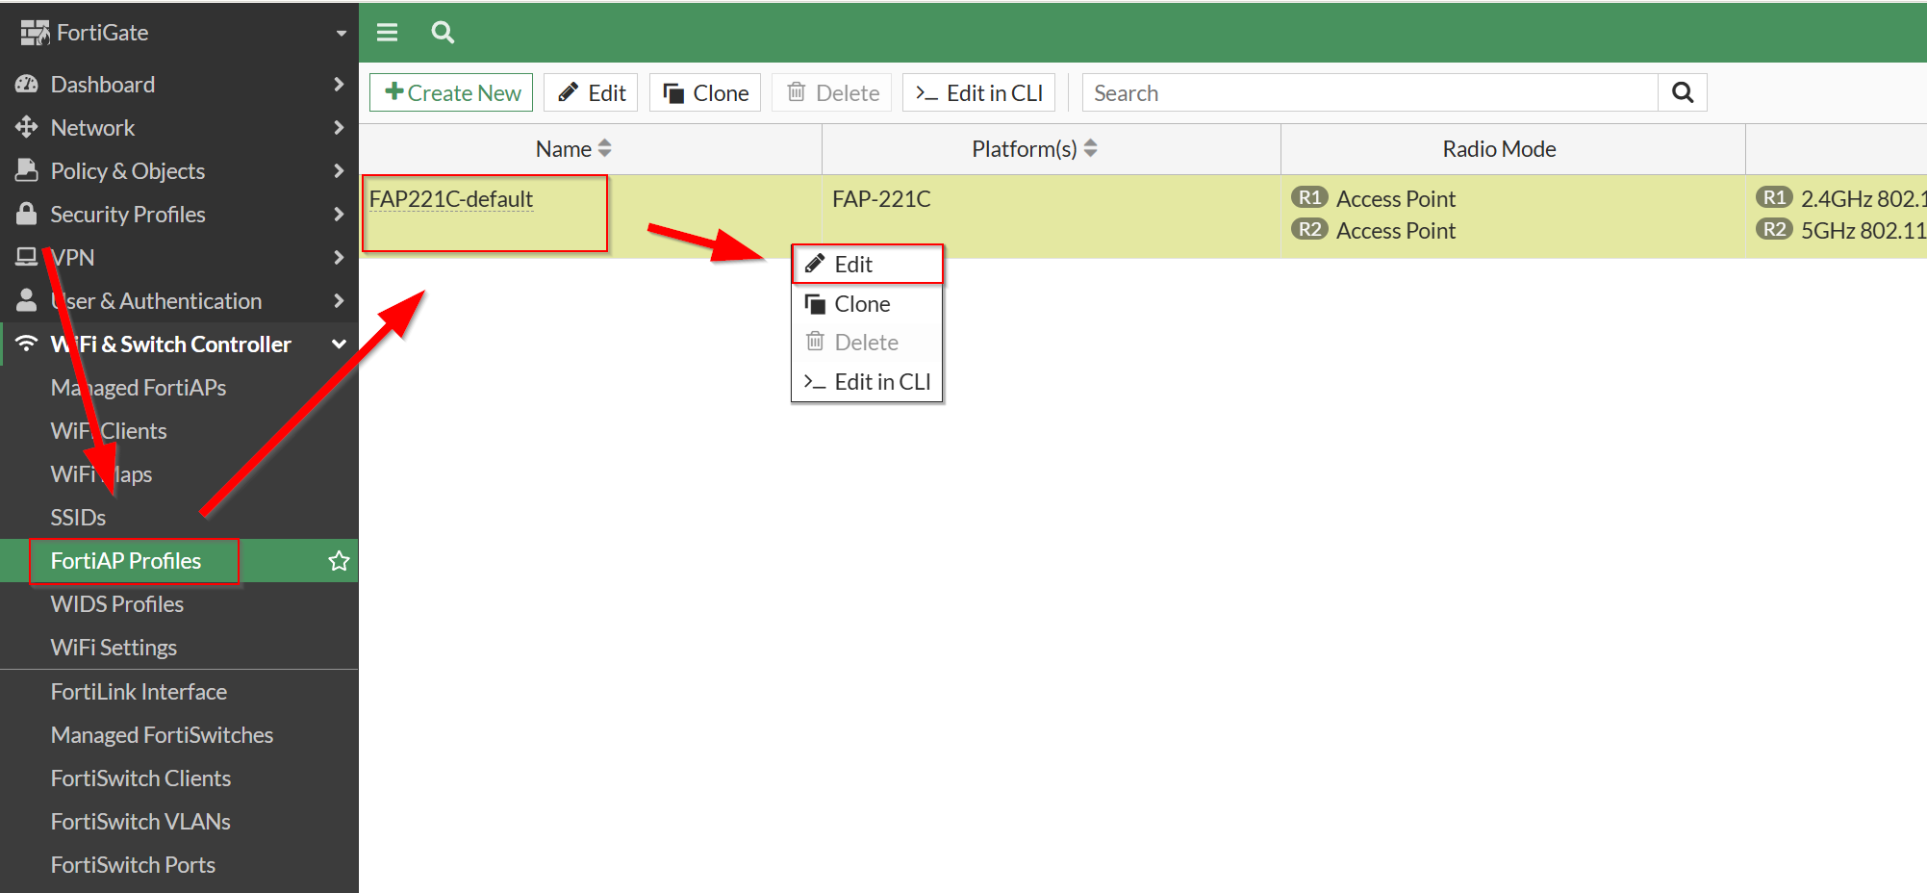

Then, copy the configuration for the FortiAP Profile.

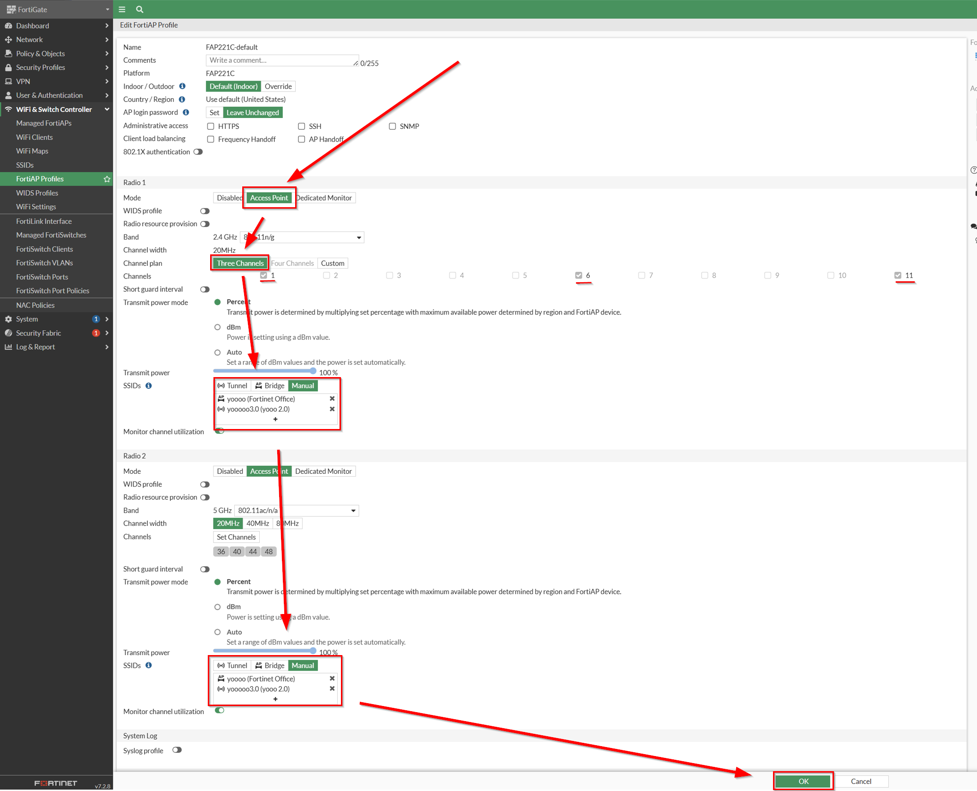

Now we have successfully integrated SSIDs into FortiAP Profiles! Next, we need to configure Firewall Policy. Head over to Policy & Objects Firewall Policy Create New Policy and put these settings.

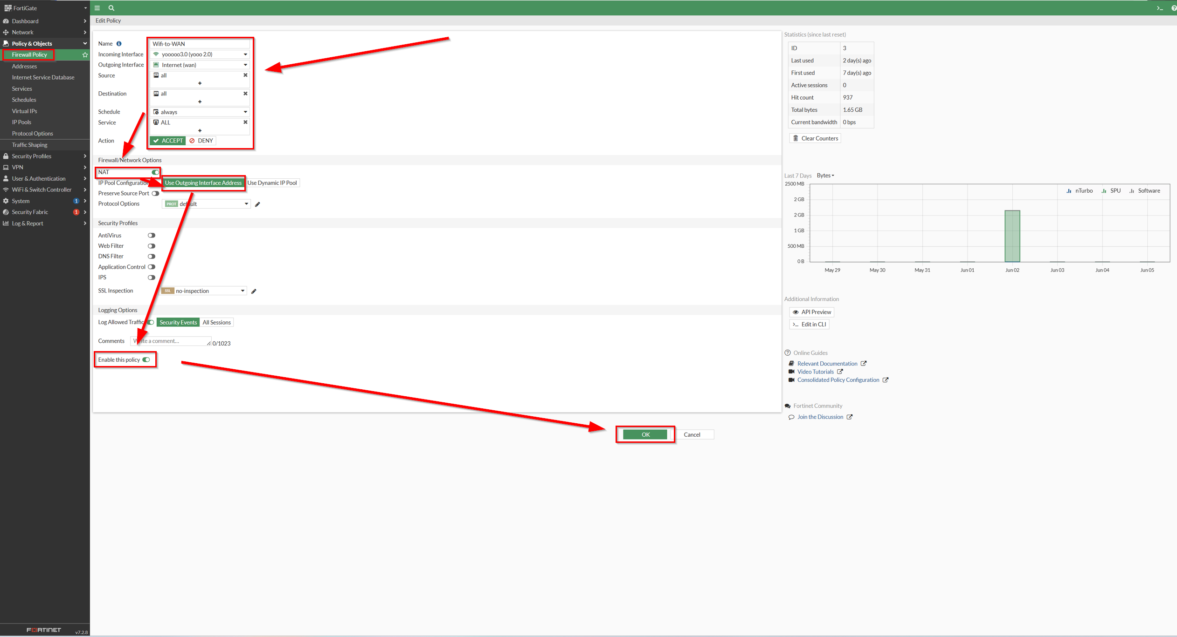

Congratulations, you have successfully configured WPA2 Personal and WPA2 Enterprise for a Fortinet environment! To test, hop on an external device within the area and use the WPA2 Personal passphrase or user credentials established from FreeRADIUS to log in and connect to the internet.
Problems:

One problem we ran into is integrating virtual machines with the FreeRADIUS server. Within the integration process, we have encountered multiple tags of problems when running command on the Linux interface. However, we soon realize that it is usually normal for errors to occur as long as they are not interfering with the integration process.

Another problem was connectivity between FortiGate to the FreeRADIUS server, but again that was supposed to be normal. In the Fabric Management section under Systems, it repeatedly says AP FortiAP is not registered. We soon realized that AP FortiAP was just a children branch from the FortiGate configuration (which was already registered) in Fabric Management. So, we found out it is fine that AP FortiAP is not registered as long as the parent is registered.

One great debugging method is using Physical Topology under the Security Fabric section. This allows a visualization of your topology, as well as being able to utilize the debug function by right clicking on a security fabric to access the debug panel, which gives you metrics and information about the functionality of your firewall.

Conclusions:

In conclusion, utilizing Fortinet for access points allows you to create an extra sense of security with specific tailored network policies at your own convenience. Being able to host SSID networks with the additional option of 2.4G + 5G also stretches the network flexibility, along with WPA2 Personal + Enterprise security.
Learning how to also host the FreeRADIUS server also is a significant skill to have especially in the tech industry, which serves as a powerful tool I have learned throughout this lab. With this lab, I have not only learned how to host SSID networks but also integrate virtual machines and radius servers into play to WPA2 security protocols.

